8.69: (This problem involves solving a quadratic. The method presented here formulates the answer in terms of the parameters, and avoids intermediate calculations, including that of the spring constant.)

Let the mass of the frame be M and the mass putty be m. Denote the distance that the frame streteches the spring by x₀ , the height above the frame from which the putty is dropped as h , and the maximum distance the frame moves from its initial position (with the frame attached) as d.

The collision between the putty and the frame is completely inelastic, and the common speed after the collision is 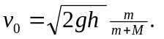After the collision, energy is conserved, so that

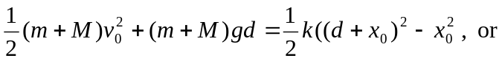
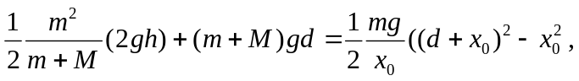

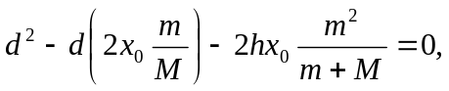where the above expression for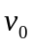, and 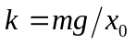have been used. In this form, it is seen that a factor of g cancels from all terms. After performing the algebra, the quadratic for d becomes

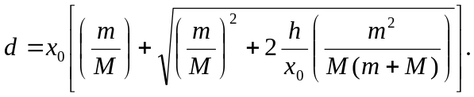which has as its positive root
For this situation, m = 4/3 M and h/x₀ = 6, so

d = 0.232 m.

